# **Caremark.com – Standard Registration Sign Up Website**

|  |
| --- |
| **Scenario/Member Statements** |

I would like to register.

My quick registration link is not working, can I still register?

Is there a way to manage my prescriptions without calling in?

|  |
| --- |
| **Registration** |

1. Have member type information and click continue.

If the member’s getting an error on their name, ensure they are entering the information as it is entered in Compass.

**Note:** If the member does not have a valid Mobile (wireless) phone number, refer to [Caremark.com – Quick Registration Enrollment(068974)](https://thesource.cvshealth.com/nuxeo/thesource/#!/view?docid=ab43ced8-612f-4de4-b671-c77c17e8bcb6).

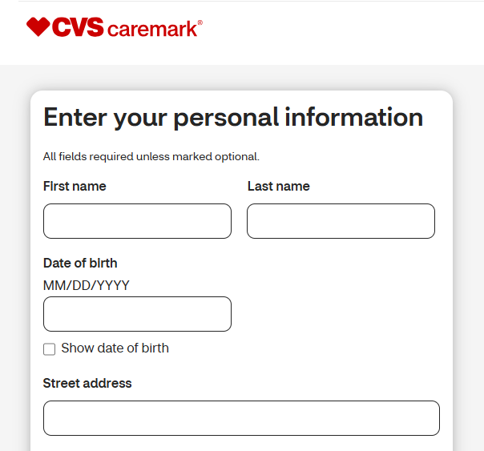

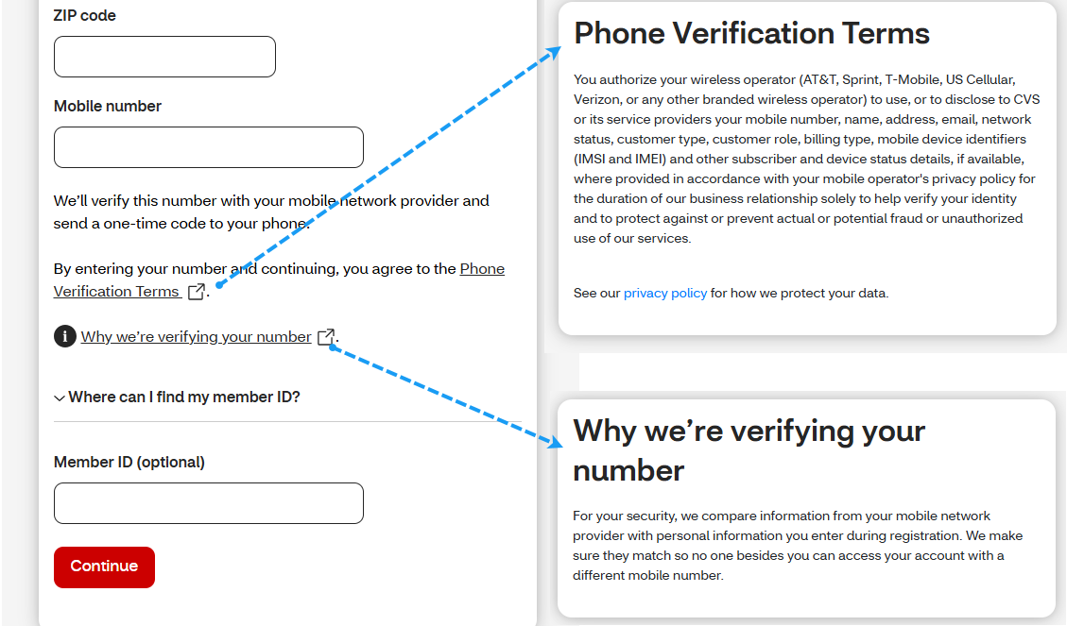

1. Have the member type information and click on continue.

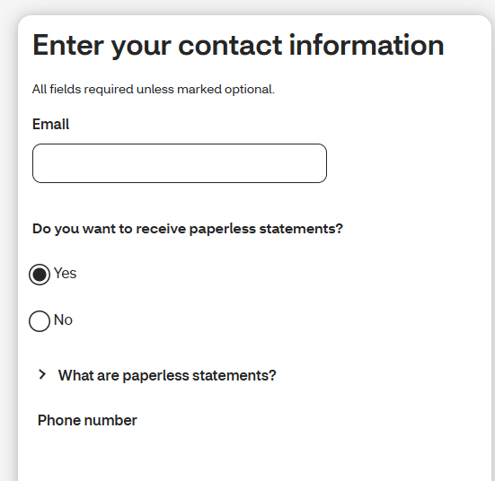

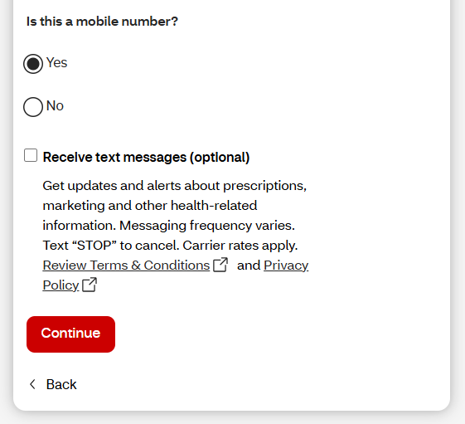

1. Have member type password information and click on continue.

**Note:** Member must agree to Terms and Conditions to proceed.

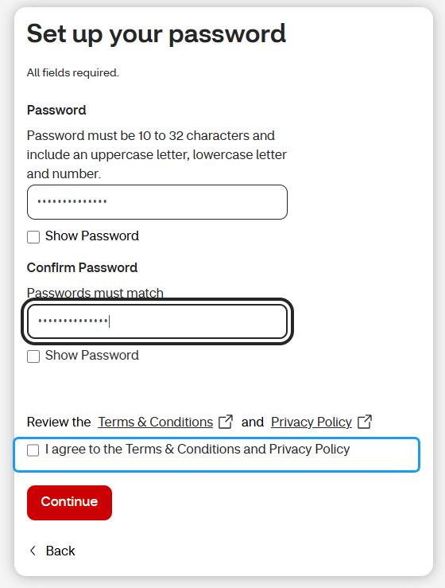

1. Member should see image below.

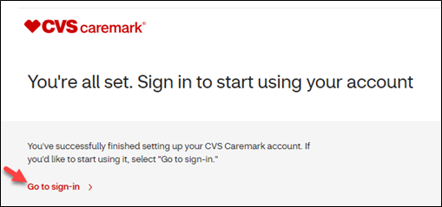

|  |
| --- |
| **Related Documents** |

[Caremark.com - Common Member Assistance Call Types Index](https://thesource.cvshealth.com/nuxeo/thesource/#!/view?docid=947b0b38-401d-4b18-a08e-60348558a9b9)

[Caremark.com – Troubleshoot Standard Registration Sign Up](https://thesource.cvshealth.com/nuxeo/thesource/#!/view?docid=002cc829-ccea-4b1c-bd0c-33ef8ddfd6ba)

**Full Details Document:** [Caremark.com – “New” Registration Flow](https://thesource.cvshealth.com/nuxeo/thesource/#!/view?docid=2922d262-0374-4a26-820b-0a5ffe1085bd)

Not To Be Reproduced Or Disclosed to Others Without Prior Written Approval

**ELECTRONIC DATA = OFFICIAL VERSION / PAPER COPY = INFORMATIONAL ONLY**